Testing project for TAROM

The scope of the final project for ITF Manual Testing Course is to use all gained knowledge throught the course and apply them in practice, using a live application
Application under test: TAROM
Tools used: Jira, Zephyr Squad.

Functional specifications:
The below stories were created in Jira and describes the functional specifications of the Plan your trip and My booking, for which the final project is performed upon.

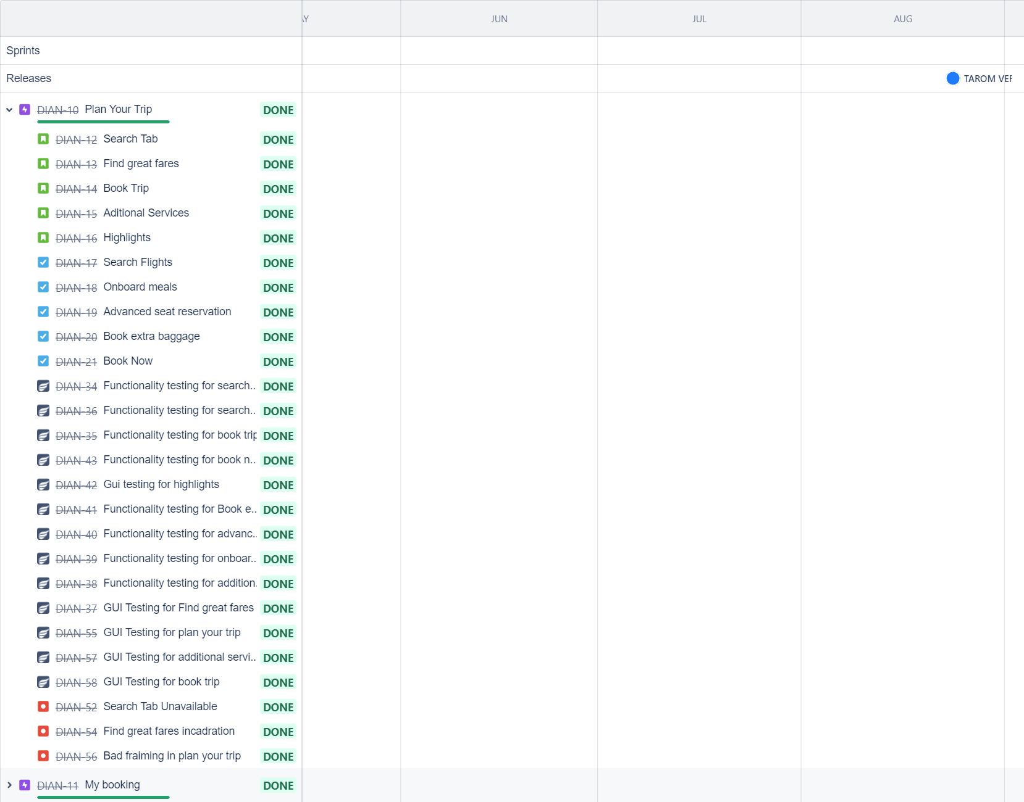

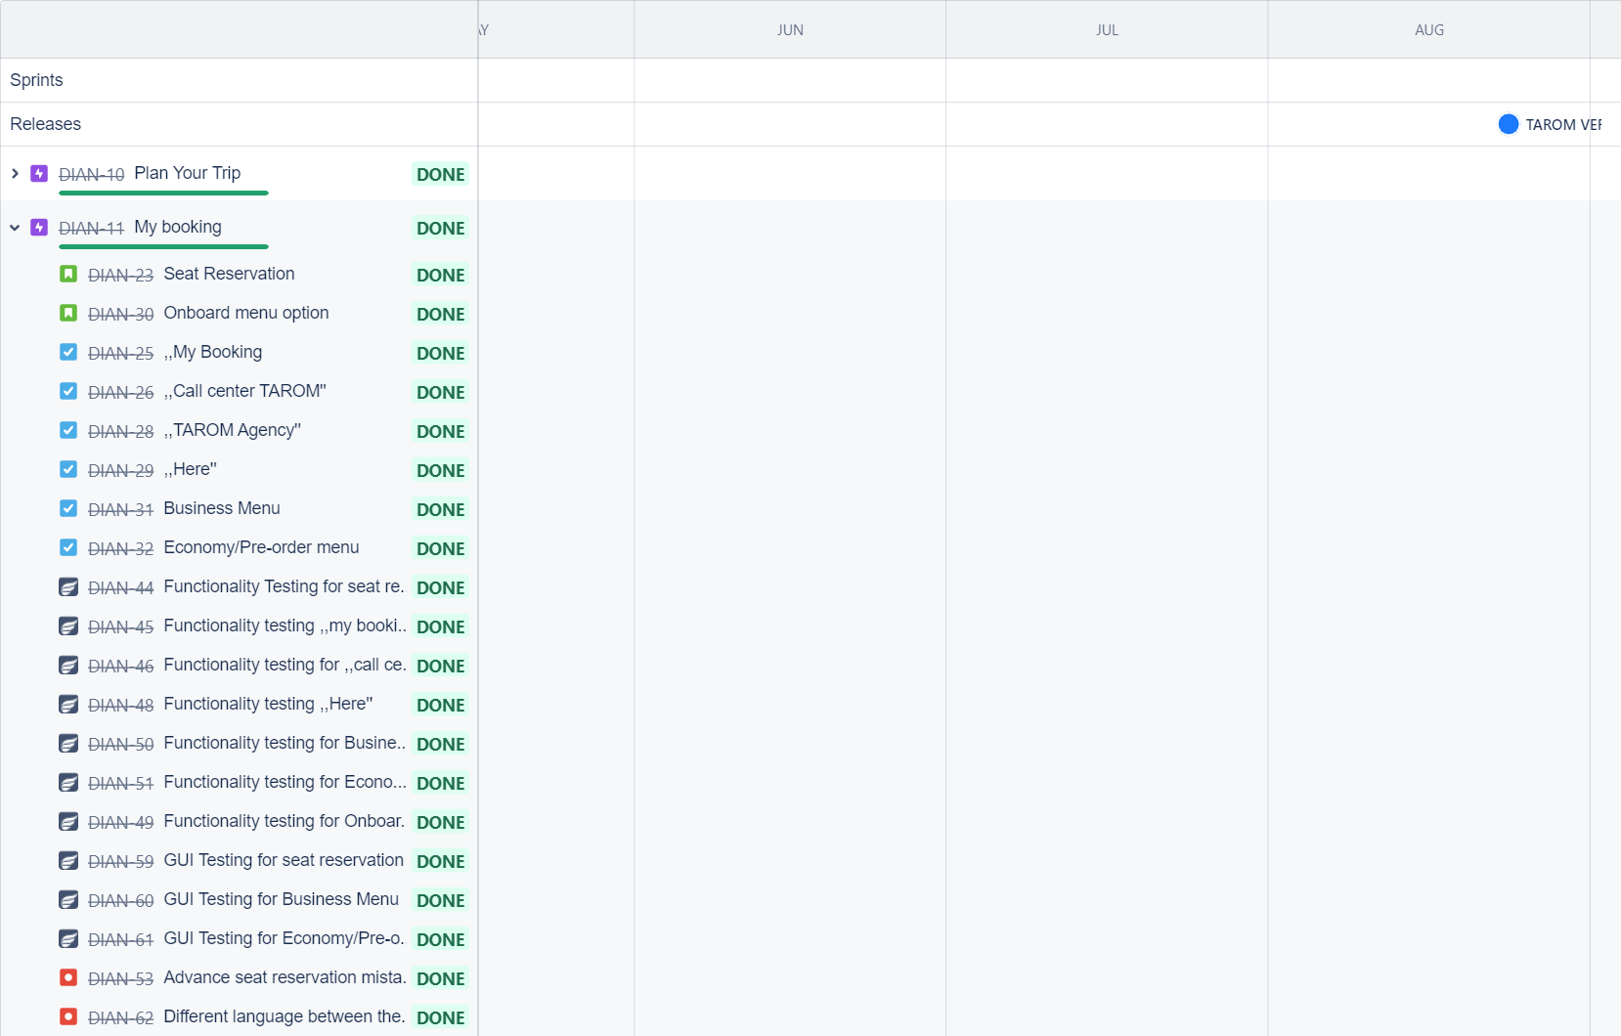
Here you can find the release that was created for this project:

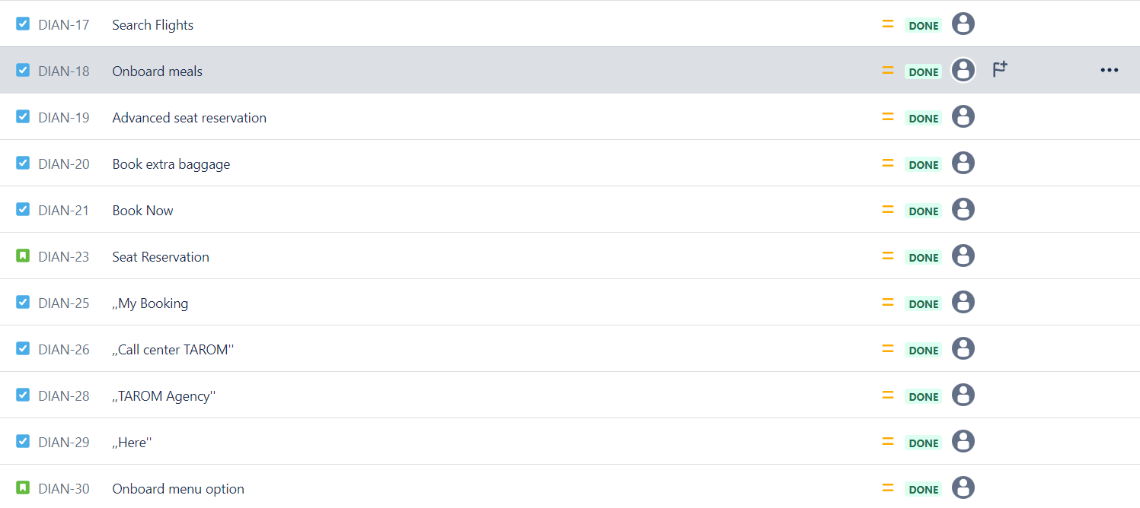
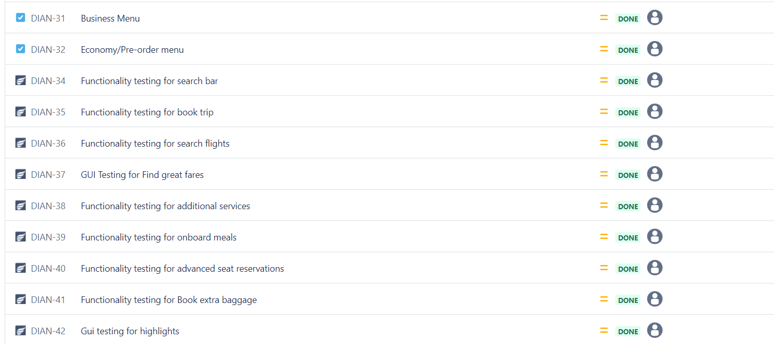

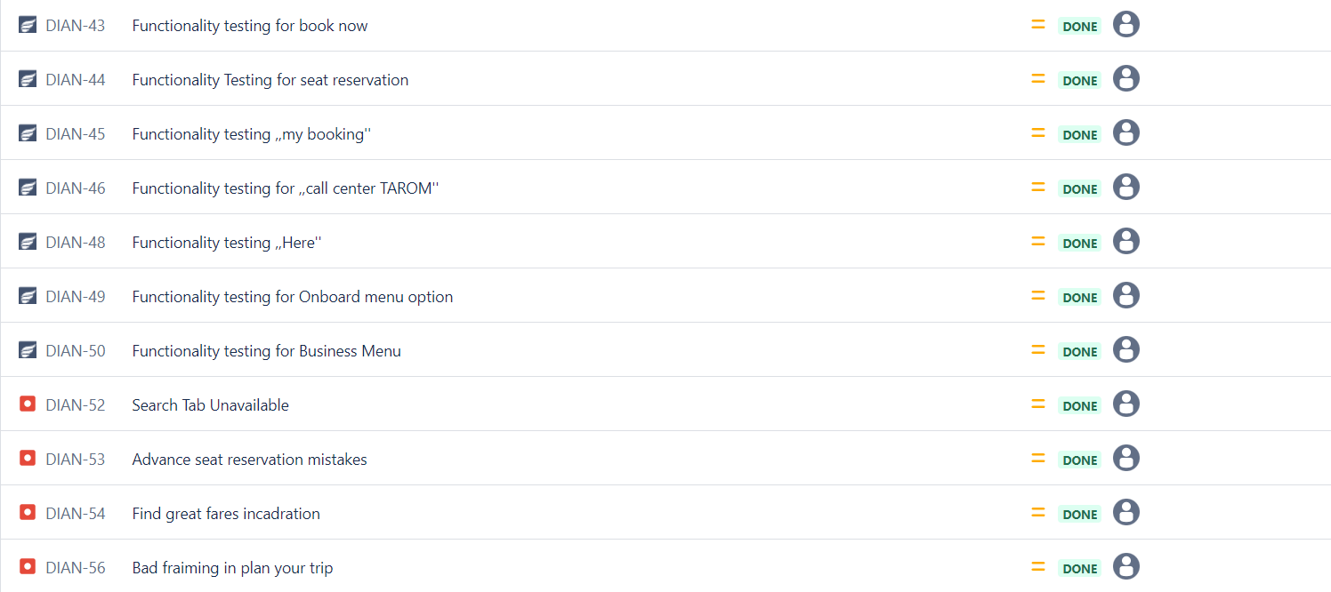
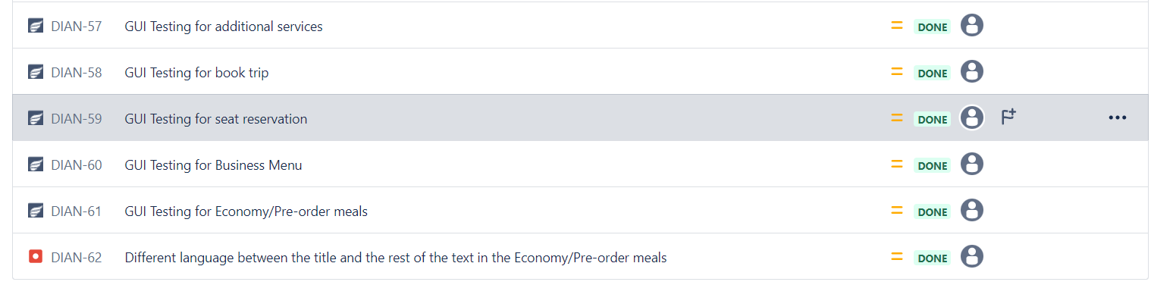

Testing process
The test process was performed based on the standard test process as described below.

1.1 Test planning
The Test Plan is designed to describe all details of testing for TAROM 2.2.2
The plan identifies the items to be tested, the features to be tested, the types of testing to be performed, the personnel responsible for testing, the resources and schedule required to complete testing, and the risks associated with the plan. The test plan that was created for this project can be found here:
https://github.com/dianabour/TAROM/blob/main/test%20plan%20TAROM%202.2.2.pdf

1.1.1. Roles asigned to the project and persons allocated
- QA Engineer: Bour Diana

1.1.2 Entry criteria defined
- Business requirements are available and agreed
- Roles and responsibilities are clear and agreed
- Project risks are identified and mitigated
- Deadline established
- Project objective established and communicated with the QA team

1.1.3 Exit criteria defined
- 95% of tests are passed
- No Critical issues have Open status
- Update tests are 100% passed (update tests will not generate other new issues that impact the application)
- Retests are passed
- regression testing is passed
- The deadline has been reached
- The objectives has been accomplished
- The testing documentation is done and communicated to the stakeholders
- The test summary report is communicated to the stakeholders
- All the defects have been documented and communicated to the stakeholders

1.1.4 Test scope
We are focusing our tests on the following areas:
1. Plan your trip:
- Search Bar
- Book Trip
- Find great fares
Additional service:
- Onboard meal
- Advanced seat reservation:
- Book extra baggage
- Highlights
- My booking:
Seat reservation:
- My booking
- Call center TAROM
- TAROM agency
- Here
Onboard menu option:
- Bussiness Menu
- Economy/Pre-order Menu
During testing, we will implement functional testing: smoke test, positive and negative, also non-functional test: performance testing,reliability.

Tests not in scope:
My booking:
-Add pet in cabin
-Add sports equipment
-Ad extra baggage
Check-in:
- Online check-in
- Check-in informations
- Mobile check-in
Informations:
- Before departure (children travelling unaccompanied, pets, passengers with special needs, transport of weapons and ammunition, prohibited and restricted goods, electronic devices/smooking on board, online booking assistance, support fot the online payment module, advanced passenger information)
- At the airport (airport security, customs clearance, lounges)
- Discover TAROM (code share flights, insight magazine, onboard services)

1.1.5 Risks detected

Project risks:
• Confusing navigation interface that could cause negative feedback from the users and, therefore, a possible loss of customers.
• Because of the short deadline the majority of tests might remain undone, and they might have functionalities problems.

Product risks:
• The web app may crash on 3rd parties’ software.
• Stability risks (crashes, disconnects, etc.)
• The older versions of Google Chrome can impact the performance.
• The opera browser may crash on this version.
• Web page pagination could be impacted when opened on mobile devices.
• New browser might not be supported.
• Some categories may not work on different languages.
• The translation on the web app is not working.

1.1.6 Evaluating entry criteria
The entry criteria defined in the Test Planning phase have been achieved and the test process can continue.

1.2 Test Monitoring and Control
We measured and analyzed continuously specific metrics to gain valuable insights, assess progress and proactively identify potential issues, offering feedback to the QA team and other stakeholders regarding the progress of sprint test cycles.
Test monitoring involves several tasks,
- Providing updates to the QA team and stakeholders about the ongoing sprint test cycles.
- Sharing the current test results with everyone involved.
- Keeping track of important test metrics.
- Planning and determining what to do next based on the tracked metrics.
The following metrics will be monitored during the testing process,
- Cost
- Schedule
- Resources
- Quality

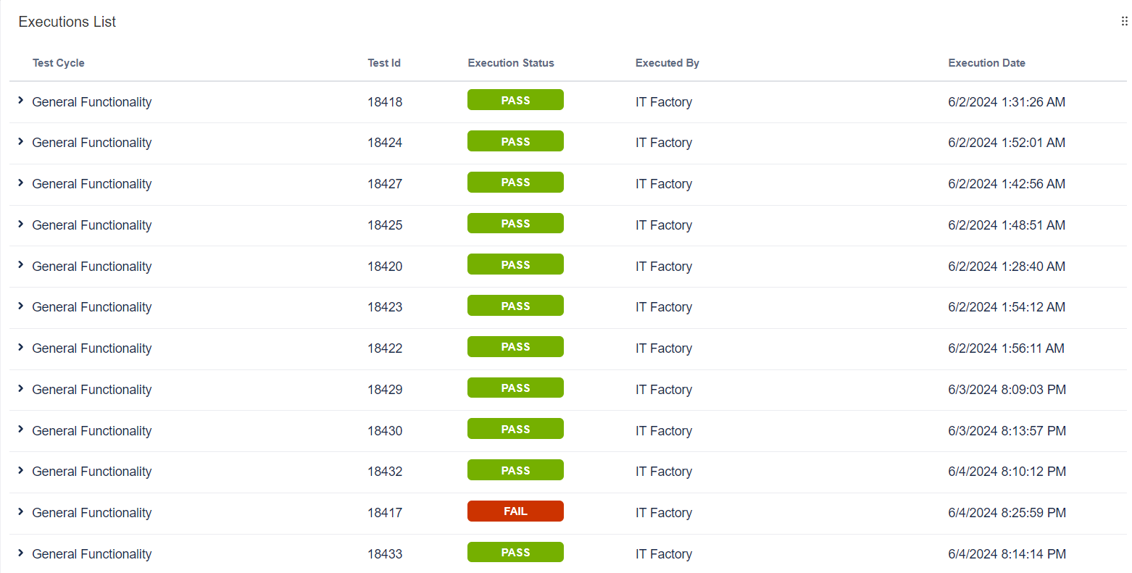
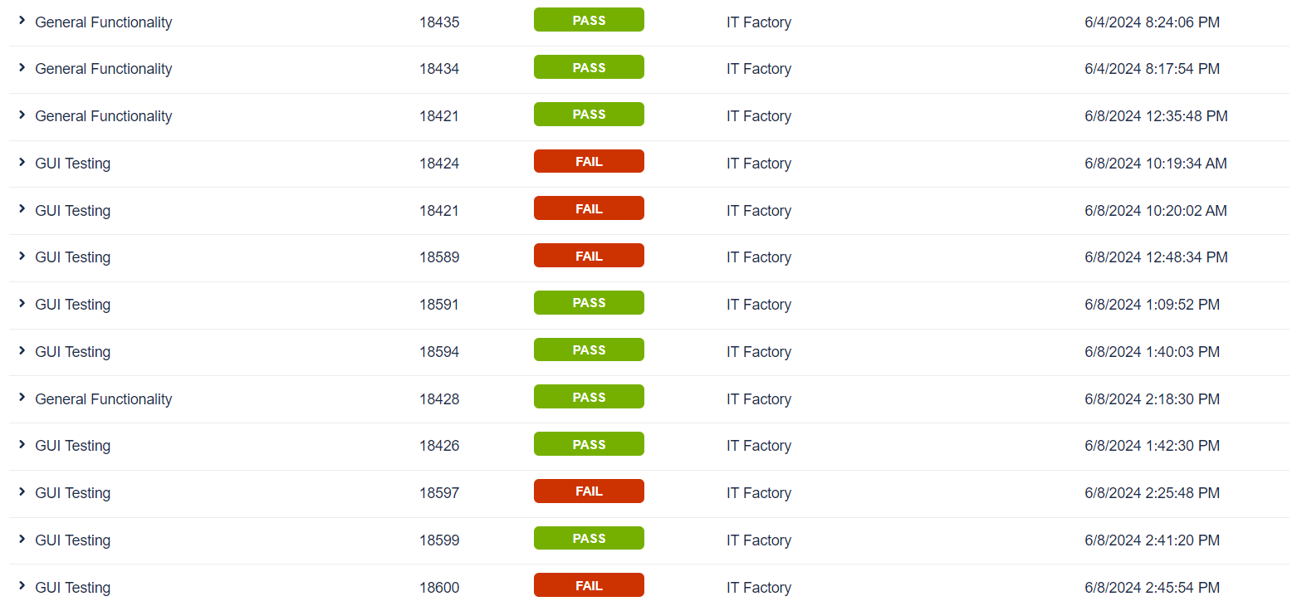

1.3 Test Analysis
The testing process will be executed based on the application requirements.
The following test conditions were found:
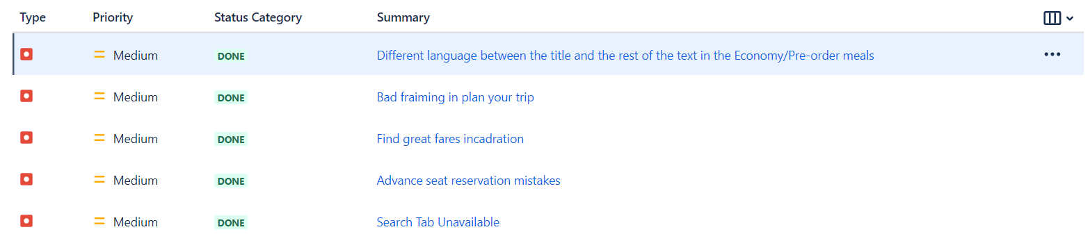

1.4 Test Design
Functional test cases were created in Zephyr Squad based on the analysis of the specifications. The test cases can be accessed here:
https://github.com/dianabour/TAROM/blob/main/ZFJ-Executions%20TAROM.csv

1.5 Test Implementation
The following elements are needed to be ready before the test execution phase begins:

- Test environment is up and running and ready for testing
- We make sure the test data is available and accurate
- We make sure we have the permissions to access the web application
- We group the most important test cases for testing
- Smoke test passed
- Permissions available

1.6. Test Execution
Test cases are executed on the created test Cycle summary:
- TAROM Testing functionality on Plan your trip and My booking
- Testing input fields where the user need to fill
- TAROM Graphical user interface (gui) and Functionality
Bugs have been created based on the failed tests. The complete bug reports can be found here:
The following is a summary of the bugs that have been found:
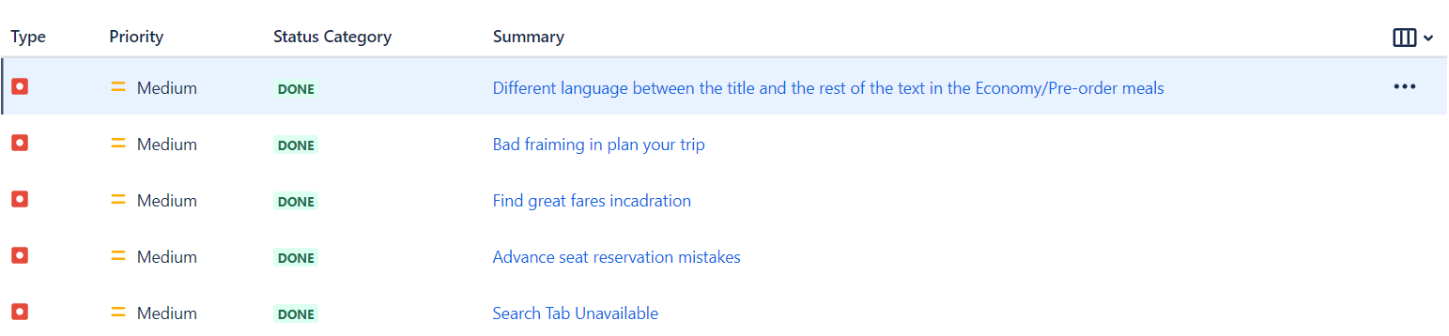
Full regression testing is needed on the impacted areas after the bugs are fixed and retesting will be done for every functionality that was previously failed.
1.7 Test Completion:
The exit criteria were met and satisfied as mentioned in the appropriate section, this feature is suggested to ‘Go Live’ by the Testing team.
The traceability matrix was generated and can be found here:
https://github.com/dianabour/TAROM/blob/main/Forward%20Traceability%20for%20TAROM.xlsx
Test execution chart was generated and can be found below.
